Title: **MicroLogix PLC Output Wiring for a Three Phase Motor** Job: 17

Course: Introduction to Automation Unit: Introduction of PLC CLO: 1, 4

Name ____________________________ Station _______ Date ______________

**Objectives**

1. Student shall understand the outputs of an Allen-Bradley MicroLogix PLC.
2. Student shall be able to transpose a wiring schematic to the physical wiring of a PLC.

**Assessment**

Students shall demonstrate a comprehension of the objectives listed above by scoring a minimum of 75% on this shop job. Grading shall be based on the Introduction to PLC rubric.

**Instructions**

Wire your Allen-Bradley (A-B) MicroLogix PLC per the schematic on the opposite side of this job sheet. Have your instructor review your work before energizing your power supply and PLC.

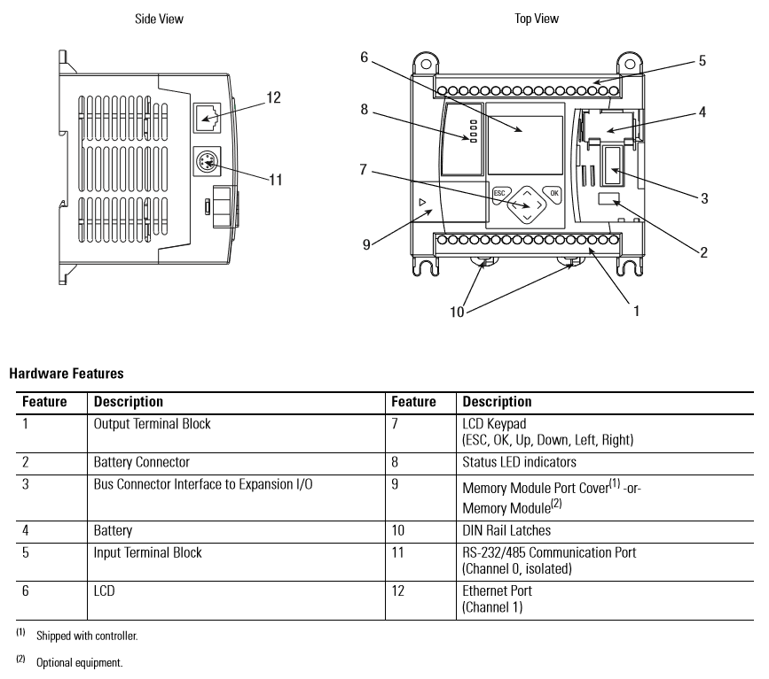

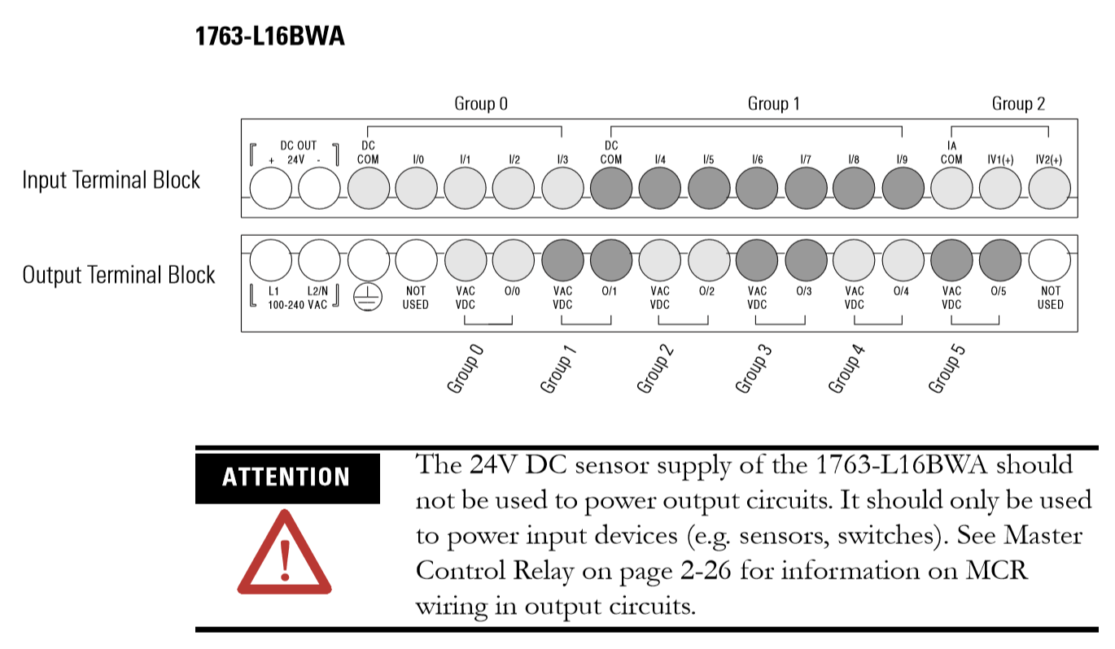



1. Have instructor approve the wiring. Instructor Initials _______